

Role Title
Examinations Services Assistant Ref: ESA 05-19

Role Information
Pay Band |  | Location |  | Duration | Reports to:
J 100% |  | Prague, Czech Republic |  | Definite, for the period of two years, initially | Examinations Services Officer - IELTS

Role purpose
To provide high quality administrative support for the delivery of British examinations in the Czech Republic to internal and external customers in order to meet customer needs and enable the British Council to meet its country specific and corporate objectives.

To ensure that all duties and activities are carried out in accordance with corporate standards and all areas of compliance of both the UK awarding bodies and British Council among others: Child Protection, Equality, Diversity and Inclusion and Data Protection.

About us
The British Council is the UK’s international organisation for cultural relations and educational opportunities. We create friendly knowledge and understanding between the people of the UK and other countries. We do this by making a positive contribution to the UK and the countries we work with – changing lives by creating opportunities, building connections and engendering trust.

We work with over 100 countries across the world in the fields of arts and culture, English language, education and civil society. Each year we reach over 20 million people face-to-face and more than 500 million people online, via broadcasts and publications. Founded in 1934, we are a UK charity governed by Royal Charter and a UK public body.

British Council Czech Republic is a cultural relations organization and one of the ways it carries out this remit is by delivering UK examinations throughout the country. The Exams Services product portfolio consists of Cambridge English Assessment examinations, IELTS and a range of university and professional qualifications (including CB delivered exams such as ACCA).

The Examinations Services team in the Czech Republic consists of nine people of which two are based in the Brno office and seven in the Prague office. The entire British Council team in Prague consists of ca 40 members.

Geopolitical/SBU/Function overview:
The English and Examinations Strategic Business Unit (E&E) is one of three strategic business units in the British Council (the others being Arts and Education & Society) all of which have the remit to build trust for the people of the UK by building relationships through aspects of our language and culture. E&E achieves this by enabling people across the world to access the life-changing education and work opportunities that are created by learning English or gaining valuable UK qualifications. Promoting the English language also provides a medium for communication, helping break down barriers of misunderstanding or mistrust between cultures. The British Council’s 2020 vision for English & Examinations is to be the world authority in high quality English language teaching, learning and assessment, as well as the International distributor of choice for UK professional and school qualifications.

The Examinations business makes a significant contribution to British Council financial sustainability, and as such, it is essential that the business evolves in order to maintain its position in a fast-changing operating context. There is a need to standardise and automate activities across the globe to deliver efficiencies, and there is also a requirement to develop new digital products and services to meet changing customer demands and competitive pressures. In a cost and resource-constrained environment, balancing the on-going requirements and allocation of funds will be critical, as will the integration and planning of the implementation of the different changes across a global network of 110+ countries charged with the on-going delivery of impact and income whilst changing key elements of the supporting operational platform.

Main opportunities/challenges for this role:
Acting in unforeseen situations to solve problems to ensure Test Day is successfully executed.
Communicating effectively when working virtually.
Managing venue staff data as per deadlines.
Liaising with administrator on resource requirements for various exams.

Organogram
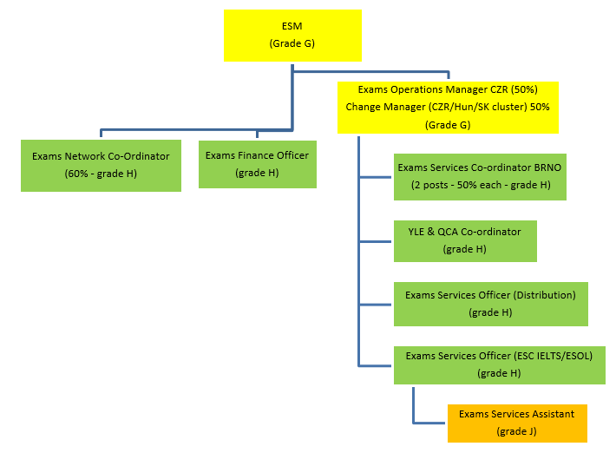
* If not visible, please see separate document “Examinations Services Czech Republic organogram”.

Main Accountabilities:
Operational support associated with exams planning and pre and post-delivery activities such as:
- support in registration procedures,
- assisting in timetabling of exams,
- maintaining up-to-date databases of venues and venue staff,
- support in managing venue staff,
- assisting in secure management of examination documentation,
- support in delivering computer-based tests,
- issuing results.
Customer Service duties such as:
- responding to customer enquiries,
- gathering and collating feedback.
General financial tasks such as:
- creating purchase orders,
- invoice receipting,
- managing Vendors,
- providing support in processing payments for Venue Staff and Temporary Staff.
General administrative tasks such as:
- managing orders for Exams Services (Office Depot),
- managing Exams Services inventory,
- providing cover for other Exams Services admin duties if required.

Key Relationships:
Internal:
- Examinations Services Manager,
- Examinations Services staff,
- Customer Services staff,
- E&E colleagues in region.

External:
- candidates,
- representatives of Exams Network,
- representatives of preparation centres (existing & potential partners),
- venue staff and speaking examners,
- representatives of UK awarding bodies.

Role Requirements:
Threshold requirements: |  |  |  |  | Assessment stage
Passport restrictions | EU country citizen and/or CZ residency / work permit holder |  |  |  | Longlisting
Direct contact or managing staff working with children? | No
Additional notes | Relevant criminal record check required.  Post may require some unsocial hours during exams periods as well as weekend work. The post may require some travel related to exams delivery.
Person Specification: |  |  |  |  | Assessment stage
Language requirements
Essential |  |  | Desirable |  | Assessment Stage
Very good working knowledge of written and spoken Czech (native level).  Good working knowledge of English (both written and spoken) (equivalent to CEF level B2 or higher). |  |  |  |  | Shortlisting and interview  Shortlisting and interview
Qualifications
Essential |  |  | Desirable |  | Assessment Stage
Leaving exam |  |  |  |  | Shortlisting
Role Specific Knowledge & Experience
Essential |  |  | Desirable |  | Assessment Stage
Track record in working with customers.  Experience in working in administrative posts. |  |  | Hands on experience in administering examinations (including computer delivered exams).  Use of SAP or similar finance management system. |  | Shortlisting and Interview  Shortlisting  Shortlisting  Shortlisting
British Council Core Skills |  |  |  |  | Assessment Stage
Communicating & Influencing (level 1) - Communicates clearly and effectively. Listens to others and expresses self clearly, with grammatical accuracy and awareness of a diverse audience in speaking and writing.  Planning & Organising (level 1) - Is methodical. Able to plan own work over short timescales for routine or familiar tasks and processes.  Managing Finance & Resources (level 1) - Uses resources efficiently.  Uses resources efficiently in own role and complies with financial rules and procedures.  Using technology (level 1) - Operates as a basic user of IT systems, digital and office technology. Able to use office software and British Council systems to do the job and manage documents or processes.  Knowledge of processes & systems related to exams in British Council Czech Republic portfolio (D) |  |  |  |  | Shortlisting and Interview  Shortlisting and Interview  Shortlisting  Shortlisting  Shortlisting
British Council Behaviours |  |  |  |  | Assessment Stage
Creating Shared Purpose (Essential level): Communicating an engaging picture of how we can work together.  Connecting with Others (Essential level): Making regular opportunities to understand others better.  Working Together (More demanding level): Ensuring that others benefit as well as me.  Being Accountable (More demanding level): Putting the needs of the team or British Council ahead of my own.  Making it Happen (More demanding level): Challenging myself and others to deliver and measure better results.  Shaping the Future (Essential level): Exploring ways in which we can add more value. |  |  |  |  | Not assessed during recruitment  Interview  Interview  Interview  Not assessed during recruitment  Not assessed during recruitment

Prepared by: | Date:
Anna Gwardys, EU Regional Ops Manager | 17th January 2019

´The British Council believes that all children have potential and that every child matters – everywhere in the world. The British Council affirms the position that all children have the right to be protected from all forms of abuse as set out in article 19, UNCRC 1989´

